|  |  |  |
| --- | --- | --- |
| ***Contact*** | ***:*** | *+8801797743116* |
| ***E-mail*** | ***:*** | [eng1902027brur*@gmail.com*](mailto:eng1902027brur@gmail.com) |
| ***Address*** | ***:*** | *Parkermor ,Rangpur* |
|  |  |  |

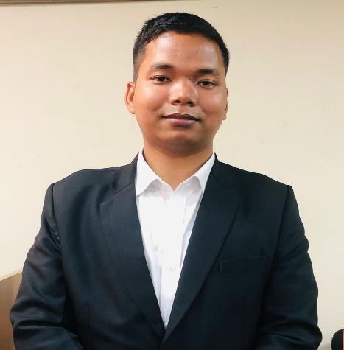

***CURRICULAM VITAE***

Brindabon Roy

*Career Objective*

"A dedicated and organized professional with strong interpersonal skills, complemented by training in Microsoft tools and technologies. Seeking a role where I can leverage my dynamic problem-solving approach, teamwork abilities, and technical expertise to contribute to organizational success while continuously learning and embracing new challenges."

Language Proficiency

* Bangla
  + *Reading*
  + *writing*
* English
  + *Reading*
  + *Writing*

*Personal Information*

|  |  |  |
| --- | --- | --- |
| Date of Birth | : | 25 June 2000 |
| Father’s Name | : | Gunadhar Chandra Roy |
| Mother’s Name | : | Urani Rani Roy |
| Nationality | : | Bangladeshi |
| Gender | : | Male |
| Permanent Address | : | Vill: Kismatsindagor, Upzila: Ranisonkoil Dist: Thakurgaon  Post office: Gogar-5120 |

Hobby

* Reading Novel
* Traveling
* Gaming

*Education Qualification*

|  |  |  |  |  |
| --- | --- | --- | --- | --- |
| **SL** | **Exam** | **Institute** | **University/Board** | **Passing year** |
| 1 | B.A | Begum Rokeya University,Rangpur | Begum Rokeya University | 2023 |
| 2 | HSC | Ranisankoil Degree College | Dinajpur | 2018 |
| 3 | SSC | Kismat Sindagar High School | Dinajpur | 2016 |

Training

* Basic computer
* Skills Development

Computer Skills

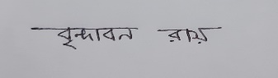

**Signature:**

Operating System

* ***MS Word***
* ***MS Excel***
* ***Power Point***